Anushka Sawant 2022

Final Year Project Report

**Forage – Project 2**

**Tata Data Visualisation: Empowering Business with Effective Insights virtual experience programme**

**TATA**

Anushka Sawant

Roll No – 726

A report submitted in part fulfillment of the degree of **BSc in Data Science and Business Analytics 2022-23 Supervisor:** Bobby Singh



School Of Data Science and Business Intelligence Patkar Varde College

Anushka Sawant, 2020-2023

**Declaration**

This report has been prepared on the basis of my own work. Where other published and unpublished source materials have been used, these have been acknowledged.

Word Count:

Student Name: Anushka Sawant

Date of Submission: 28/11/2022

TATA Data Visualization Anushka Sawant

**Table of Contents**

Project Introduction

Certificate Scan Copy

Task 1 – Framing the business scenario.

• Task Introduction

• Task

• Resources

Task 2 – Choosing the right visuals.

• Task Introduction

• Task

• Resources

Task 3 – Creating effective visuals.

• Task Introduction

• Task

• Resources

Task 4 – Communicating Insights and Analysis.

• Task Introduction

• Task

• Resources

TATA Data Visualization Anushka Sawant

**Project Introduction:**

Being a consultant, an online retail store has requirements to review its data and provide insights that would be valuable to the CEO and CMO of the business. The business has been performing well and the management wants to analyze what the major contributing factors are to the revenue so they can strategically plan for next year.

The leadership is interested in viewing the metrics from both an operations and marketing perspective. Management also intends to expand the business and is interested in seeking guidance into areas that are performing well so they can keep a clear focus on what’s working. They would also like to view different metrics based on the demographic information that is available in the data.

I need to draft the relevant analytics and insights that would help evaluate the current business performance and suggest metrics that would enable them to make the decision on expansion.

It consisted of 4 Tasks:

1. Framing the business scenario.
2. Choosing the right visuals.
3. Creating effective visuals.
4. Communicating Insights and Analysis.

**Certificate:**

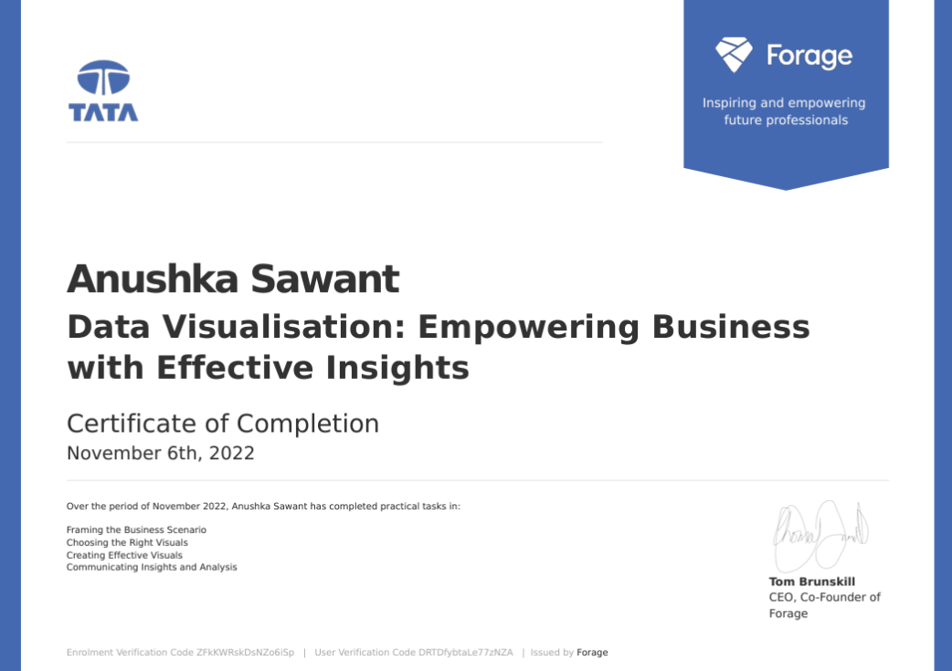

TATA Data Visualization Anushka Sawant

**Task 1: Framing the business scenario.**

**Task Introduction:**

The first thing to do is to draft questions that will be important and relevant to the CEO and CMO. This preparation will act as a guide to developing the presentation. The questions were framed both quantitatively and qualitatively. A dataset was provided to use as the basis for exploration. Reviewed this data, taking note of what information has been provided, what insights can garner, and what is relevant to both the CEO and CMO respectively.

**Task:**

Created a set of 8 questions:

For CEO,

* What percentage of overall income are the top customers responsible for? Are these customers essential to the company's success, or are the customers more diverse?
* What quarters had the most revenue? Are sales impacted by the seasons?
* Which region is producing the most profit, and which region is producing the least?
* What is the trend for revenue on a monthly basis, and which months have seen the highest rise or fall in revenue?

For CMO,

* How long does it take for returning customers to place their next purchase after receiving the first one?
* How many customers make the same purchases again and over again? Do they place similar orders or do they place distinct orders?
* Who are the consumers who have returned the most frequently? What percentage of the revenue do they contribute?
* Which consumers have placed many orders and how much profit is generated by them?

Answered 8 MCQs on the portal itself.

**Resources**

* Word Document

TATA Data Visualization Anushka Sawant

**Task 2: Choosing the right visuals**

**Task Introduction:**

To provide visuals on the metrics that they wish for the online retail store. Gathering the requirements and providing them with the type of visual that would be best suited to the scenario. The senior management wants to understand how their business is performing and what areas are the key strengths of the company. They are also focused on identifying opportunities that would lead to growth and generate more revenue in the future.

**Task:**

Answered 5 Multiple Choice Questions on the portal itself where we need to select the perfect visual on the basis of the scenarios given and its requirements.

**Resources**

TATA Data Visualization Anushka Sawant

**Task 3: Creating Effective Visuals.**

**Task Introduction:**

The first thing to do is to draft questions that will be important and relevant to the CEO and CMO. This preparation will act as a guide to developing the presentation. The questions were framed both quantitatively and qualitatively. A dataset was provided to use as the basis for exploration. Reviewed this data, taking note of what information has been provided, what insights can garner, and what is relevant to both the CEO and CMO respectively.

**Task:**

Performed data cleaning and removed blanks from the data.

Created a check in Power BI that the quantity should not be below 1 unit.

Created a check in Power BI that the Unit price should not be below $0.

Created the visuals around four of the questions that the CEO and CMO had requested in PowerBI.

Answered all four questions, one on each page

1. Time series of revenue for the year 2011 depicting season trends.
2. Top 10 countries generating the highest revenue, excluding the United Kingdom.
3. Top 10 customers, focusing on the customers generating the highest revenues. Depicting that the greatest revenue-generating customer at the start gradually declines to the lower revenue-generating customers.
4. Demand of products, regions having high demands for these products.

**Resources**

* Power BI

TATA Data Visualization Anushka Sawant

**Task 4: Communicating Insights and Analysis.**

**Task Introduction:**

Presenting findings to the CEO and CMO. They are interested in the thought process and how the data is handled, cleaned and visualized. It is important to explain thought process and ideas in a clear and straightforward way. Presenting the analysis of all four questions from the previous task. Presenting well-versed findings from the data and the conclusions made from your analysis.

**Task:**

Presenting the analysis of all four questions from the previous task. Presenting well-versed findings from the data and the conclusions made from your analysis.

Developed a script and recorded a video presenting the findings to the CEO and CMO based on the four questions they asked and the visuals created in the previous tasks.

The script included the entire process, including the initial data load and clean-up steps in providing error-free analysis.

**Resources**

* Word Document
* MP4